Secuirty Processor Details

Information about trusted platform module(TPM)

Custom WMI inventory configuration:

Path: Settings-> Asset and Inventory Management -> Custom Inventory-> Custom WMI Items

Namespace : root\cimv2\security\microsofttpm
Class: win32_tpm

Attribute Name: specVersion
DisplayName: specVersion

Screenshot:

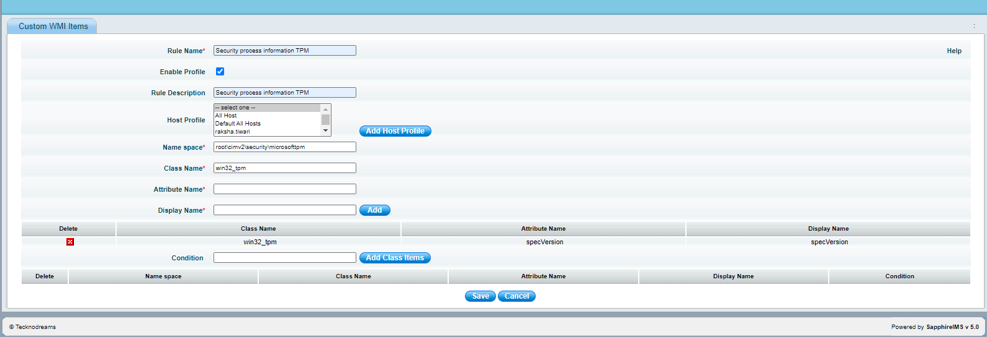

Next Step:

Once the custom inventory is collected, contact SapphireIMS support to provide custom report.

