Running Elasticsearch in different Host
Version: v1.0
Last Updated: 28-MAY-2019

Document Control
Document Name | Running Elasticsearch in different Host
Associated Documents | Running Elasticsearch in different Host
Author | Haranath Reddy
Distribution | Tecknodreams Software consulting Pvt Ltd.
Version History | Version | Date | Description |  | Update By
 | 1.0 | 28/05/2019 | Initial draft

Copyright
Copyright © 2019 Tecknodreams Software Consulting Pvt. Ltd. All Rights Reserved.

Restricted Rights Legend
This documentation is subject to and made available only pursuant to the terms of the Tecknodreams License Agreement and may be used or copied only in accordance with the terms of that agreement. It is against the law to copy the documentation except as specifically allowed in the agreement. This document may not, in whole or in part, be copied photocopied, reproduced, translated, or reduced to any electronic medium or machine readable form without prior consent, in writing, from Tecknodreams.

Information in this document is subject to change without notice and does not represent a commitment on the part of Tecknodreams.

Contents
Introduction 3
Steps to Running elastic search in different host 3
Stopping Services 3
Installing JDK 8 3
Setting Java Home 3
Copying/Installing Elastic Search 6
Removing Dependency 6
Database changes 7
Starting Services 7

Introduction

This document will explain how to run elastic search in different host

Steps to Running elastic search in different host
- Stopping Services
- Installing JDK 8
- Setting Java Home
- Copying/Installing Elastic search
- Removing dependency
- Database changes
- Starting Services

Note: SapphireES host is the machine where elastic search need to be placed/ migrated

Stopping Services

- Go to SapphireIMS installed machine
- Go to Services
- Stop the “SapphireLogAnalyzer” service
- Stop the “SapphireIMS ES” service

Installing JDK 8

- Create the folder SapphireES in C Drive where elastic search needs to be placed (Assuming the folder is created in C drive)
- Go to SapphireIMS installed host
- Navigate to <SapphireIMS Installed Path> in file explorer
- Copy JDK folder
- Go to SapphireES host and navigate to SapphireES folder (created in Step 1)
- Paste the JDK folder copied in Step 4

Setting Java Home

- Go to SapphireES host

- Right click on This PC/My Computer and click Advance System Settings

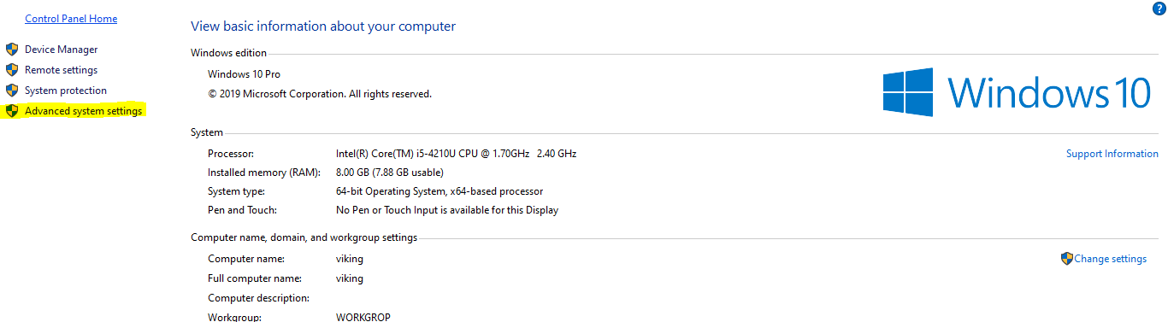
- Click on ‘Environment Variables’ button
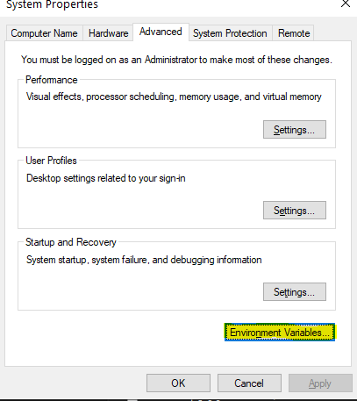

- Click on ‘New’ button in System Variables

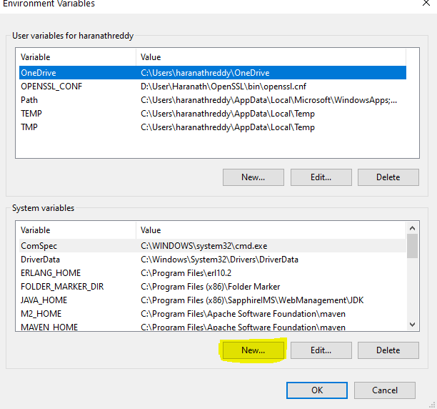
- Enter variable Name as JAVA_HOME
Variable Value as C:\SapphireES\JDK and click on ok button
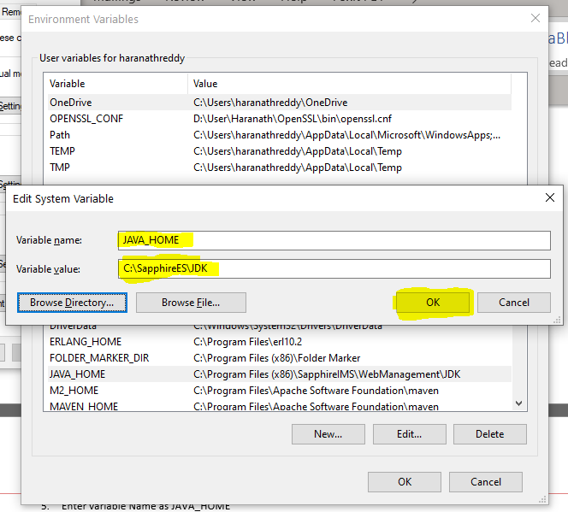

- Click on ‘ok’ button

Copying/Installing Elastic Search

- Go to SapphireIMS installed Machine
- Navigate to <Sapphire Installed Path>\ Plugins\LogAnalyzer
- Copy elasticsearch folder
- Go to SapphireES host and past the copied elasticsearch folder into “C:\SapphireES” folder
- Run the command prompt in Administrator mode
- Navigate to “C:\SapphireES\elasticsearch\bin” (Eg: cd c:\SapphireES\elasticsearch\bin)
- Type the following command
elasticsearch-service.bat install “SapphireES”
- Go to services Start the SapphireES service

Removing Dependency
- Go to SapphireIMS installed machine
- Open command prompt as administrator
- Run the following command
sc config "SapphireLogAnalyzer" depend= /
- Navigate to <Sapphire Installed Path>\ Plugins\LogAnalyzer\upgrade\DREC12536 and open run.bat in text editor
- Find the “localhost” text and replace with SapphireES host IP address
- Save the file

Database changes
- Open MySQL query browser and connect to SapphireIMS database
- Execute the following Update query

UPDATE loganalyzer_outputsettings SET eshostname = '172.16.9.30'

Note: change the IP Address to SapphireES host IP Address

Starting Services

- Go to SapphireIMS installed machine
- Go to Services
- Start the “SapphireLogAnalyzer” service

Note: “SapphireIMS ES” service is not required to run in SapphireIMS server

