Windows 10 Feature Pack Deployment
Creator Update Configuration & Troubleshooting Guide
Last Updated: 10-Aug-2020

Table of Contents
Introduction 3
Downloading and using feature packs 3
Steps to download ISO image from the above link 4
Best Deployment Practice 7
Deploying feature packs using SapphireIMS 7
1. Availability of feature pack 7
2. Creation and scheduling of deployment profile 9
Feature Pack Deployment Flow 11
Step-1: Windows 10 Pre-requisite validation 11
Step-2: Windows 10 feature pack download 12
Step-3: Windows 10 Pre-installation validation 12
Step-4: Windows 10 Installation validation 13
Step-5: Windows 10 post install validation 14
Config Settings Control 14
Tracking the Download Status 15
Tracking the Job Status 15
Known Error Codes 16

Introduction

Windows10 version updates are released as feature packs and each version of Windows 10 released will have 18 months support from Microsoft. Post this period, the devices running with outdated versions will no longer receive monthly security and quality updates that contains protection from latest security threats. To continue receiving security and quality updates, Microsoft recommends that you update the system to the latest Windows version.
For more information on versions ‘End of Service’, refer following
https://support.microsoft.com/en-us/help/4023814/some-versions-of-windows-10-display-a-notification-to-install-the-late
Deploying feature packs are tricky as dependency files (ISO files) are required. This documentation gives you best practices to follow when deploying features packs using SapphireIMS tool.
Run through compatibility check which is available under Important Notes section from following link to make sure minimum requirements are met.
https://www.microsoft.com/en-us/windows/windows-10-specifications?howto

Downloading and using feature packs

The windows packs can be download the ISO also from Microsoft Software Download center provided that you have a license key to deploy the package. Extract the ISO file and create the zip package which needs to be pushed for the target system.
Note: Ensure that the editions, architecture and OS languages of your machines are compatible with the downloaded ISO file.

Steps to download ISO image from the above link

Download the ‘MediaCreationTool2004.exe’ from the below given link.
Use ‘Download tool now’
https://www.microsoft.com/en-in/software-download/windows10
Note: MediaCreationTool2004.exe filename will get vary based on the current released OS version
Launch this ‘MediaCreationTool2004.exe’ file to download respective OS bit 32/64-bit Windows 10 ISO image.
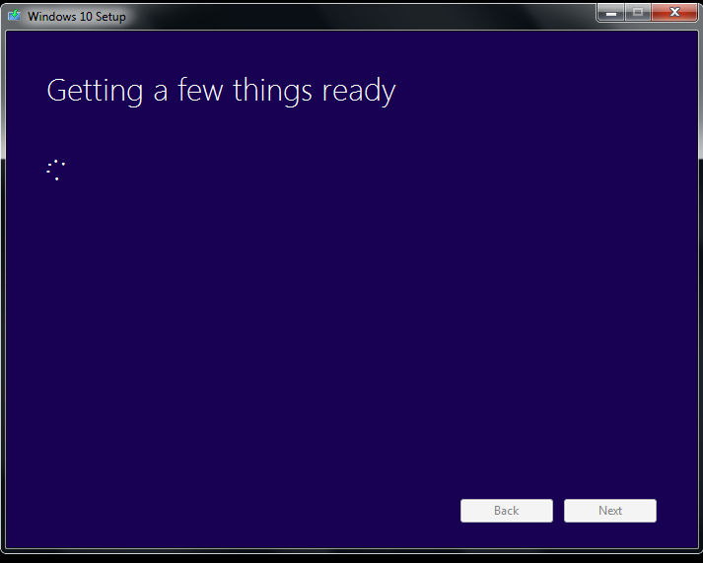
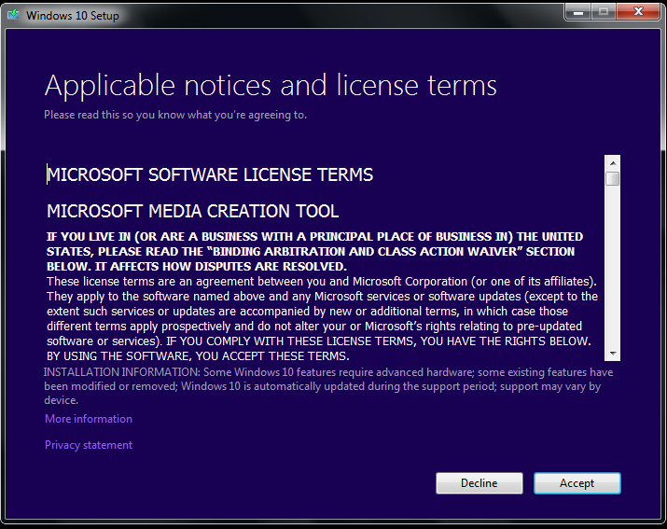

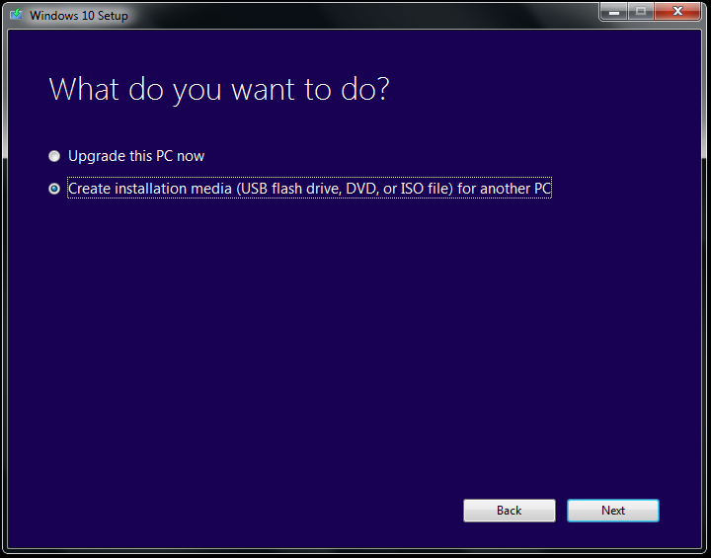
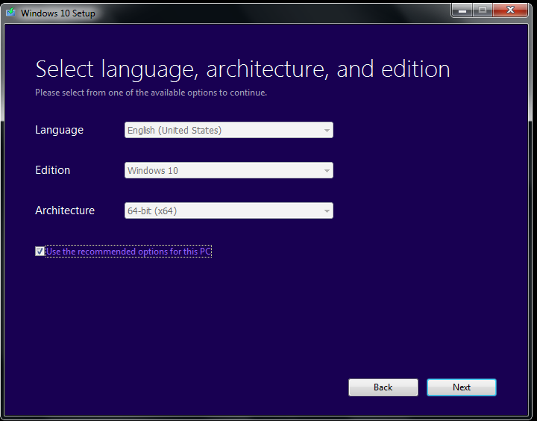
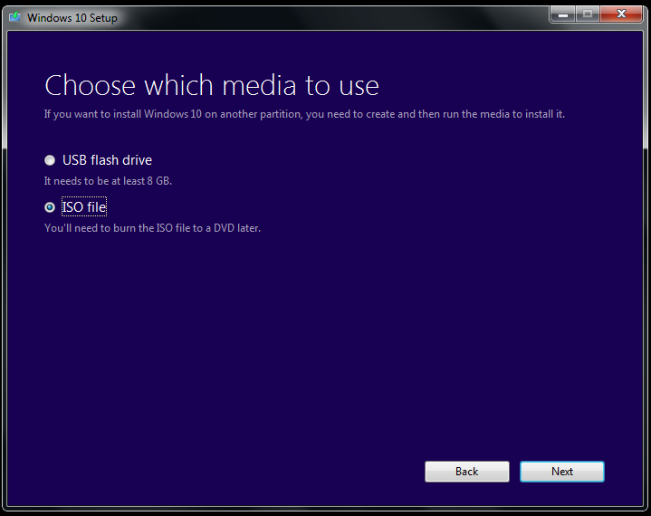

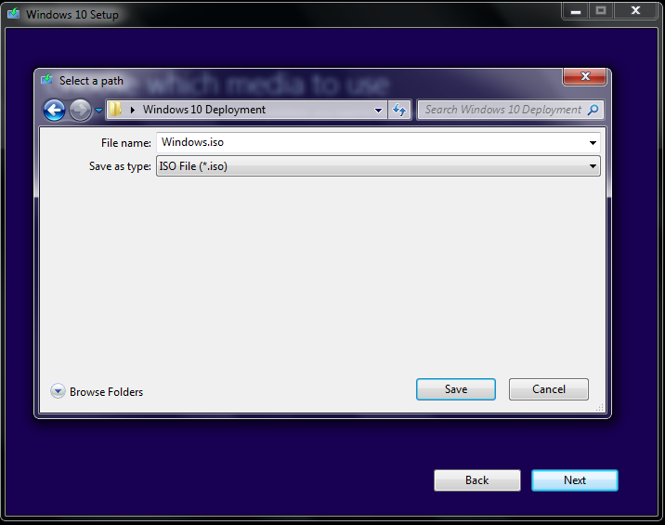
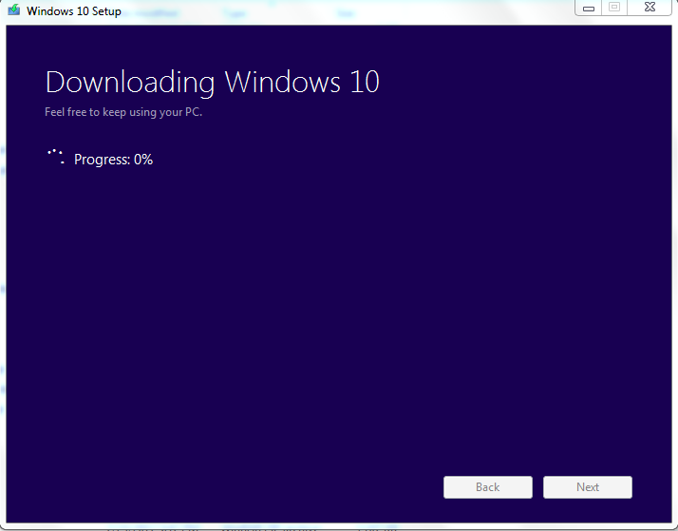
Once ISO file downloaded, right click on the file to extract it ‘Windows’ folder. Transfer the downloaded ISO file to SapphireIMS Server.

Best Deployment Practice

Unlike any software deployment job in SapphireIMS, Windows10 feature pack deployment needs to be a planned activity with proper deployment architecture for following reasons
- The feature packs will be in GBs size and will hit the bandwidth consumptions
- Machines to be up, running and connected to SapphireIMS during deployment which may be in hours of time
- The master agents or file servers to be up and running and post feature pack deployments the targeted machines needs to be rebooted for feature packs to take into effect

Guidelines
- Make sure pre-requisites are addressed and plan this activity
- When posting jobs for agents leverage master-slave architecture. Plan to upgrade master agents and slave agents separately as during slave agent’s deployments master agents should be up and running
- If SapphireIMS server is hosted on cloud, use Remote Share option and plan the deployment activity

Deploying feature packs using SapphireIMS

Availability of feature pack

Once the feature pack is ready, create a package and place at
- Following location to use by agent as well as agentless machines (Local Machine option)

<Installed-Path>\SapphireIMS\ConsoleManagement\ExternalWar\SoftwareRepository.war

- In one of file server which is directly accessible to corresponding master, standalone agents and agent-less machines (Remote Share option)

Steps to create a package file

SapphireIMS Windows10 feature packs filenames should start with ‘win_10’
example: win_10WindowsFeaturePack_10_en_x64.zip
- A folder to be created with the filename and place all the feature pack files inside the folder. Make sure `setup.exe` is present within it

- Copy the “setuproolback.cmd” and “setupcomplete.cmd” which is attached below. Then place it under the same directory.

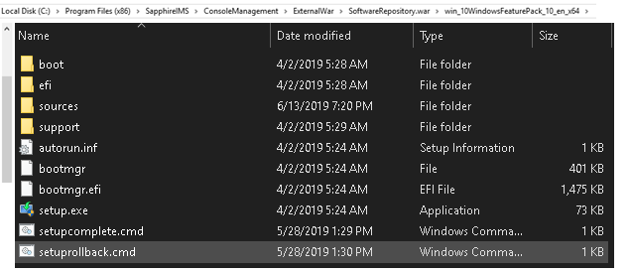
- Zip the folder and make sure the zip filename will be <Filename Formed>.zip

- Zip the folder and make sure the zip filename will be <Filename Formed>.zip

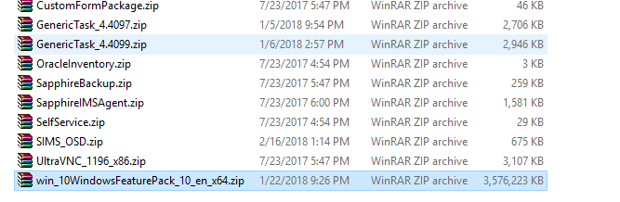
Note: In case of MSP (enterprise plus), you can create a dummy file at server however, the actual file needs to be placed in all of probes and add-on probes. In case of enterprise edition, all of data collectors should have the feature pack files placed.

Creation and scheduling of deployment profile

Navigate to Setting->Software Management->Windows10 Feature Pack Deployment
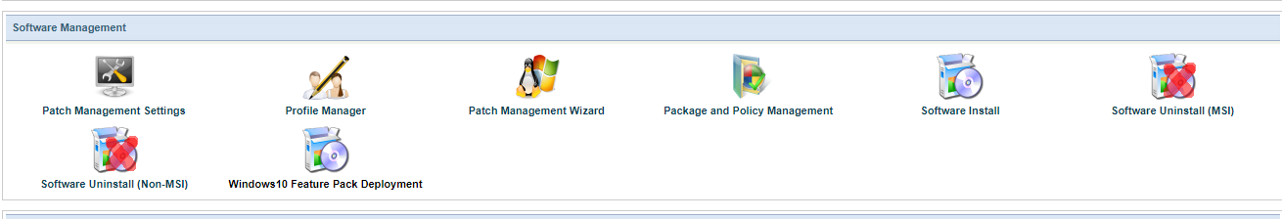

Click Add
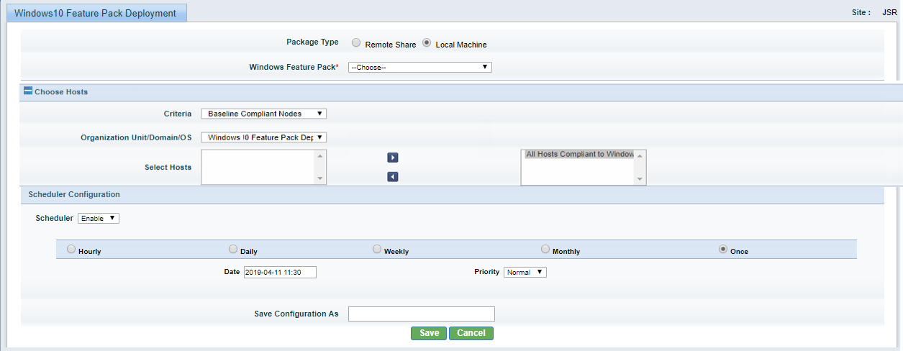

On selection of Local Machine, the added packages will be listed under Windows Feature Pack. Select appropriate package and targeted host(s) using inclusion host profile.

Note: You can use Individual IP or Baseline Compliant Nodes to select machines with appropriate hardware and software configuration of your interest. Make sure you un-necessary don’t select host(s) not of interest to load server and network.
Schedule a time to process deployment job.

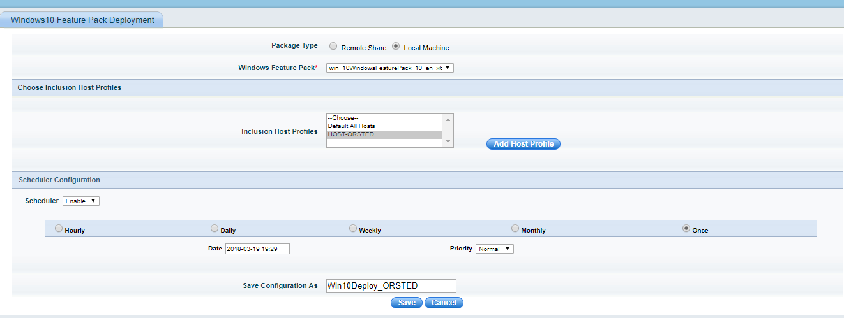

Using Remote Share for package
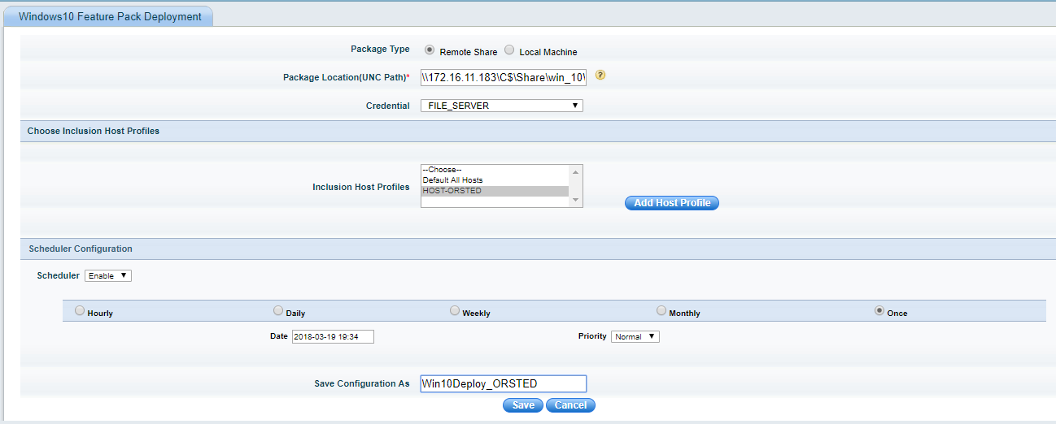

You can choose Remote Share in case there is a local file server accessible to master agents or standalone agents or agent-less machines. In such case, the feature pack doesn’t go to SapphireIMS to download and rather uses local shares to copy.
In this case, it is very important to note while selecting host(s) for deployment, select only those machines which have access to the share.
The package location is UNC path with format \\<IPAddress or Hostname>\Path\File Name; example: \\172.16.11.183\C$\share\ win_10WindowsFeaturePack_10_en_x64.zip
If the share requires credentials to access, choose Credential profile. These profiles can be added under Settings->Asset and Inventory Management->Profile Manager

Feature Pack Deployment Flow

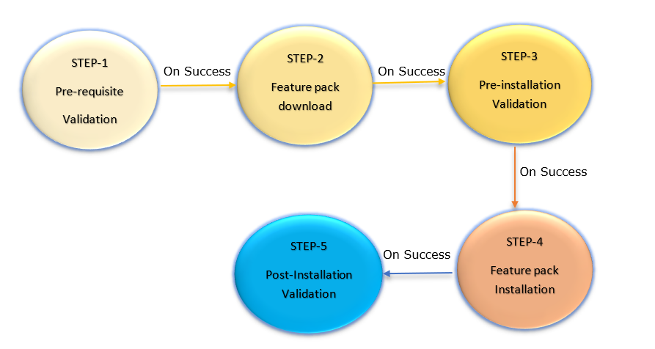

Step-1: Windows 10 Pre-requisite validation
This step is required to prevent the windows 10 deployment fail over due to pre-requisite validation.

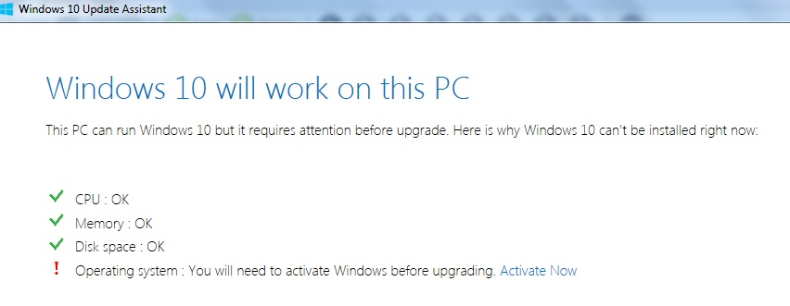
- https://www.microsoft.com/en-in/software-download/windows10
- https://www.microsoft.com/en-in/windows/windows-10-specifications
- The pre-requisite validation can be different for different windows 10 versions, further this validation can be brought into the server side and make as configurable
- We can pre-ship various validations metrics up to current released build version. If customer is using the latest build and if metrics are changed, customer can override the defaults
- This validation is done by the windows assistance before start downloading the packages from the internet
https://download.microsoft.com/download/9/4/E/94E04254-741B-4316-B1DF-8CAEDF2DF16C/Windows10Upgrade9252.exe

Step-2: Windows 10 feature pack download

- Downloading the Windows Installer from the SapphireIMS Server and preparation of the next step.
This downloads update file whose size shall be more than 3GB
Note:
Here need to validate the downloader with more size and robust. Once the download completed this phase will be closed. The downloader will support the multi part download file which will help to avoid the much data loss during the shutdown issues.
As the download has been modified to support multi-part hence its required 2 times of space of the any downloads (Example if the Package size is 2 Gb then Agent required free space of 4gb to download this package). Once the package successfully downloaded it will remove the additional space which is occupied in the target system

Step-3: Windows 10 Pre-installation validation

This step will get executed post the windows 10 installer downloaded from the server and post validation of the checksum
SETUP.EXE /Auto Upgrade /Quiet /NoReboot /DynamicUpdate Disable /Compat ScanOnly
When you run this ScanOnly execution, the results are returned via return codes from SETUP.EXE itself.
Return Code | Error Description
0xC1900210 | No issues found
0xC1900208 | Compatibility issues found (hard block)
0xC1900204 | Migration choice (auto upgrade) not available (probably the wrong SKU or architecture)
0xC1900200 | Does not meet system requirements for Windows 10
0xC190020E | Insufficient free disk space

https://blogs.technet.microsoft.com/mniehaus/2015/08/23/windows-10-pre-upgrade-validation-using-setup-exe/

Step-4: Windows 10 Installation validation

During this step we will execute the Setup.exe with the configured parameter and then we will capture the error code. This will help to debug if its failed or not.
Exit code name | Exit code | Cause
CONX_SETUP_EXITCODE_CONTINUE_REBOOT | 0x3 | This upgrade was successful.
CONX_SETUP_EXITCODE_RESUME_AT_COMPAT_REPORT | 0x5 | The compatibility checks detected issues that require resolution before the upgrade can continue.
CONX_SETUP_EXITCODE_AUTO_INSTALL_FAIL | 0x7 | The installation option (upgrade or data only) was not available.
https://docs.microsoft.com/en-us/windows-hardware/manufacture/desktop/windows-setup-command-line-options

This helps to make the job status properly based on the setup.exe return code post the job execution

Step-5: Windows 10 post install validation

This will help to get the final and proper error status of the Windows 10 installation.
Postoobe - This command/batch will get executed post the success of the installer
Postrollback- This will get executed post the failure of the installer

Config Settings Control

WIN_10_PRE_VALIDATION_PAR- This will hold the pre-validation command line switches. If need to add any further parameter, we can use this config setting
WIN_10_PREVALIDATION_EXIT_CODE- This will hold the exit code which is considered as success without even checking the ignorable exit codes. If any new pre-validation exit code required, we can use this config setting
WIN_10_POST_VALIDATION_EXIT_CODE - This will hold the exit codes which are considered as valid after the Windows10 installation. This setting was introduced because these exit code can add up in further based on the customer environment. So, pre-validation can be controller using this config settings
WIN_10_IS_REBOOT_ENABLE - This will hold the value to indication what action to perform post installation (1-Reboot and 2-Infinite snooze). The default value we are suggesting keeping it as 2
WIN_10_IGNORABLE_EXIT_CODE - This will hold the exit code which can be ignore after pre installation validation. Same as WIN_10_POST_VALIDATION_EXIT_CODE, but this is used for deployment control
WIN_10_SNOOZE_INTERVAL - This will have the snooze interval in minutes between each snooze.
DOWNLOAD_BYTE_SIZE - This will define the size of the download part file applicable. The default value is 50000000. This value should not be set beyond 500000000.

Tracking the Download Status

To track the download job status swinformer table can used by using the below new columns
- createdtime - This will hold the time when the first download file was created.
- modifiedtime - This will hold the last modification time of the recent part file
- actualbandwidth - This will show us the actual bandwidth in which the agent has downloaded the recent file.
- byteSize - This will show us the size in bytes of each part file getting downloaded in the agent side.
- statusdescription - This will show us the reason for download failure if any.
- md5checksum - This will hold the MD5 checksum of the download file.
- oldDownloader - This field need to be set to 1 before checksum calculation to fallback to old downloader. This can used as the fall back downloader incase if we have faced any issue in the new downloader logic

Tracking the Job Status

JobStatusDetails table will get an entry for each job which is getting posted and appropriate updates will be done from the end machine to update the real-time status bar accordingly.
- SiteID - Since this is a dynamic table, we are including the SiteID column.
- SchedularID - The schedularid for the job.
- JobID - Will be the unique identifier for a posted job.
- SystemID - Systemid for which the job is posted.
- JobTypeID - JobTypeID of the posted job.
- Status - This column will hold the status being updated from the end machine.
- Timeperiod - This will hold the status update time for each update on this table for debugging purposes.
- SubTypeId - This is to differentiate between two jobs sharing the same JobTypeID.(EX: Software Installation and windows 10 deployment)

Known Error Codes

- Error code reference link:
https://support.microsoft.com/en-in/help/10587/windows-10-get-help-with-upgrade-installation-errors
- Execution timeout-PreInstallationValidation Failed-Windows 10 Installation Failed:
Need to retrigger the job
- Exit Code-->0x80070003-Windows 10 Installation Failed:
Refer the below link to rectify this error code.
https://docs.microsoft.com/en-us/windows/deployment/upgrade/upgrade-error-codes
https://docs.microsoft.com/en-us/openspecs/windows_protocols/ms-erref/18d8fbe8-a967-4f1c-ae50-99ca8e491d2d
0x00000003 ERROR_PATH_NOT_FOUND The system cannot find the path specified.
Request you to perform manual Windows 10 ISO image file to check the results.
- Exit Code-->0x80070013-PreInstallationValidation Failed-Windows 10 Installation Failed:
Refer the below link to rectify this error code.
https://answers.microsoft.com/en-us/windows/forum/windows_10-update/windows-10-update-error-0x80070013/c254cbd3-506c-4823-982a-c95db0337c54
OR
https://docs.microsoft.com/en-us/windows/deployment/upgrade/upgrade-error-codes
https://docs.microsoft.com/en-us/openspecs/windows_protocols/ms-erref/18d8fbe8-a967-4f1c-ae50-99ca8e491d2d
0x00000013 -ERROR_WRITE_PROTECT - The media is write-protected.
Request you to perform manual Windows 10 ISO image file to check the results.
- Exit Code-->0x80070020-PreInstallationValidation Failed-Windows 10 Installation Failed:
Refer the below link to rectify this error code.
https://docs.microsoft.com/en-us/windows/deployment/upgrade/upgrade-error-codes
https://docs.microsoft.com/en-us/openspecs/windows_protocols/ms-erref/18d8fbe8-a967-4f1c-ae50-99ca8e491d2d
0x00000020 - ERROR_SHARING_VIOLATION - The process cannot access the file because it is being used by another process
Request you to perform manual Windows 10 ISO image file to check the results.
- Exit Code-->0x8007042B-Windows 10 Installation Failed:
Refer the below link to rectify this error code.
https://docs.microsoft.com/en-us/windows/deployment/upgrade/upgrade-error-codes
https://docs.microsoft.com/en-us/openspecs/windows_protocols/ms-erref/18d8fbe8-a967-4f1c-ae50-99ca8e491d2d
0x0000042B - ERROR_PROCESS_ABORTED - The process terminated unexpectedly.
Request you to perform manual Windows 10 ISO image file to check the results.
- Exit Code-->0xB7-PreInstallationValidation Failed-Windows 10 Installation Failed:
Refer the below link to rectify this error code.
https://docs.microsoft.com/en-us/windows/deployment/upgrade/upgrade-error-codes

https://docs.microsoft.com/en-us/openspecs/windows_protocols/ms-erref/18d8fbe8-a967-4f1c-ae50-99ca8e491d2d
0x000000B7 - ERROR_ALREADY_EXISTS - Cannot create a file when that file already exists.
Request you to perform manual Windows 10 ISO image file to check the results.

- Failed to download file from MasterAgent ServerIP :: 1016012150 Port :: 46001 With Error Code 10060:
Telnet connectivity failed from slave to master agent
- -PreInstallationValidation Failed-Windows 10 Installation Failed:
Cross check OS architecture and reconcile whether respective OS architecture (32 or 64 bit) ISO package has been selected while posting the job.
- Exit Code-->0x8007001F-PreInstallationValidation Failed-Windows 10 Installation Failed:
Refer the below link to rectify this error code.
https://docs.microsoft.com/en-us/windows/deployment/upgrade/upgrade-error-codes
https://docs.microsoft.com/en-us/openspecs/windows_protocols/ms-erref/18d8fbe8-a967-4f1c-ae50-99ca8e491d2d?redirectedfrom=MSDN
0x0000001F ERROR_GEN_FAILURE A device attached to the system is not functioning.
https://answers.microsoft.com/en-us/windows/forum/windows_10-update/issues-while-installing-creators-update-0x8007001f/79d29604-5423-40f5-b4fe-90462c267f43
Request you to perform manual Windows 10 ISO image file to check the results.
- Exit Code-->0x8007000D-PreInstallationValidation Failed-Windows 10 Installation Failed:
Refer the below link to rectify this error code.
https://docs.microsoft.com/en-us/windows/deployment/upgrade/upgrade-error-codes
https://docs.microsoft.com/en-us/openspecs/windows_protocols/ms-erref/18d8fbe8-a967-4f1c-ae50-99ca8e491d2d?redirectedfrom=MSDN
0x0000000D ERROR_INVALID_DATA The data is invalid.
Request you to perform manual Windows 10 ISO image file to check the results.
- Exit Code-->0x80070490-PreInstallationValidation Failed-Windows 10 Installation Failed:
https://answers.microsoft.com/en-us/windows/forum/all/how-do-i-fix-error-code-0x80070490windows-update/38fa3ffc-6361-4c14-83d3-13bc5c3a9047
- Exit Code-->0xC190020E-Windows 10 Installation Failed:
https://answers.microsoft.com/en-us/windows/forum/all/error-code-0xc190020e-when-installing-update/fe8d375b-7b9d-4787-ba02-016729224a2c

