- Go to Settings ->User Management -> Users ->Additional User Info
- Configure user additional field for Lat Long
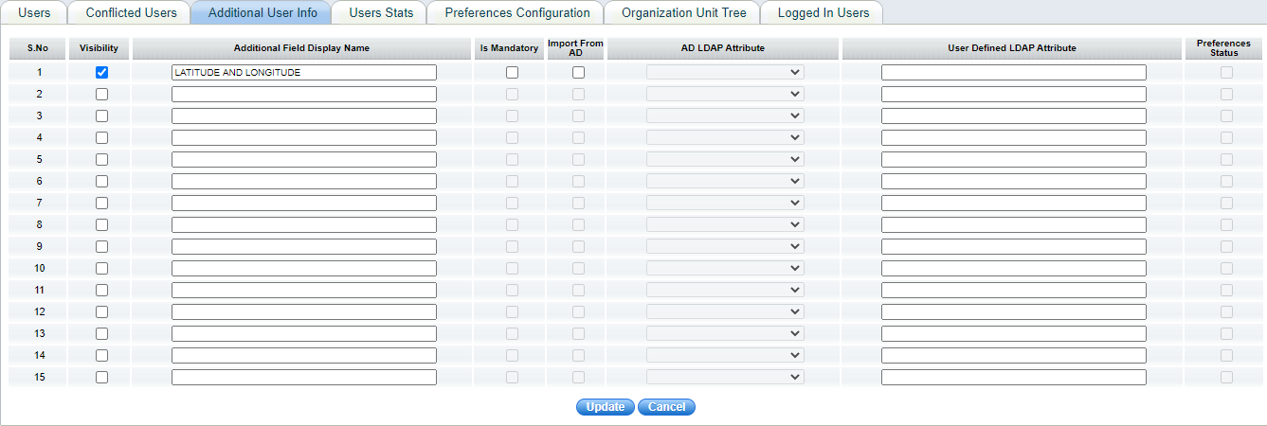
- Go to User configuration screen
- Provide user current location manually (lat long comma separated)
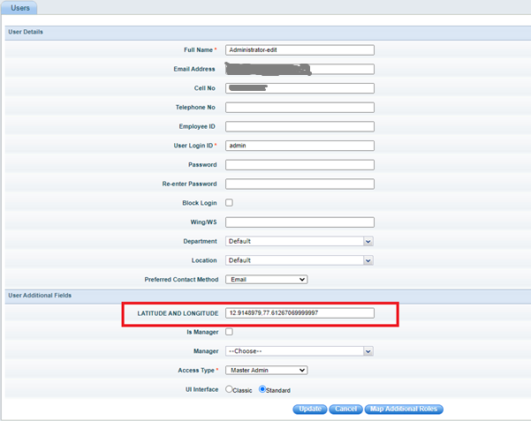
- Configure Lat & Long for many users with default Lat Long value
- Users must be Signed in from mobile and GPS must be enabled
- Submit a ticket from mobile
- Go to Assign state, nearby available Technicians it will display in the map
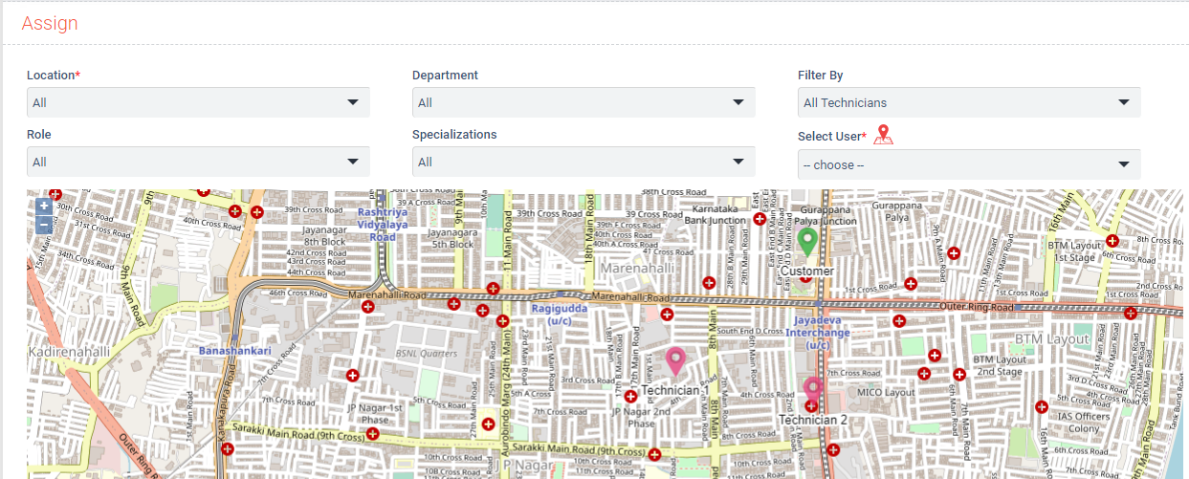

Note:
- Latitude Longitude Service Interval Time – Define the interval to capture user location-Default 5mins
- Purge interval for capturing of Latitude Longitude Service - default 2 days

